The East Bridgewater Conservation Commission
Guide to Wetlands and Permitting
The intent of this document is to inform the public about wetlands, water bodies (resource areas) and how to go about permitting work in or near them. Unfortunately, there have been times where a property owner was not aware that their property contains areas which are jurisdictional under the Massachusetts Wetlands Protection Act. This has at times resulted in large amounts of time and money spent to restore those areas which were altered without a permit and would not have otherwise been permitted. This document is also intended to aid in the future prevention of those situations by educating the public and directing them to contact the Conservation Commission if they are unsure about potential wetlands or waterbodies on or near their property as they relate to work a property owner may wish to undertake.

Living in Massachusetts, you may have heard of the Wetlands Protection Act and Regulations (310 CMR 10.00). This law says that wetlands are important for a variety of functions and that we all share in the stewardship responsibilities to keep wetlands clean. This law requires anyone doing work or any activity as defined in the law near or in a wetland, river, stream, or pond to obtain a wetland permit from the Conservation Commission. This law applies to homeowners and developers alike. The Conservation Commission is tasked with upholding this state law. Under Massachusetts laws you are responsible for obtaining the permit even if you do not know you are required to obtain one.

Asking the Conservation Commission about a project first informally will help avoid costly delays. It is important to never hesitate to call the Conservation Commission office about a project. A quick phone call and possible site visit by the Conservation Agent prior to work can prevent enforcement situations which could cost property owners large amounts of time and money.

Examples of work or activities that generally require permits are, including but not limited to:
• Construction
• Land clearing
• Additions and Garages
• Parking lots, roads and subdivisions
• Cutting and clearing vegetation (some exemptions apply)
• Retaining walls
• Wells (irrigation, point, drinking water)
• Septic systems
• Pools, decks and some sheds
To begin to analyze your property for possible wetlands/waterbodies, there is free and readily available information you can reference. For recently purchased property, some of that information may be available in your closing documents. The easiest thing to do is to contact the Conservation Commission if you are unsure. All permit applications and permits are public information and stored in the Conservation Office. The property you may wish to inquire about could have an existing file at town hall.
*Please be aware that just because there may be no previous permit issued on the property, that does not mean that one may not be needed for future work.
There are several resources available on the internet, such as aerial photographs, soil maps, and other resources to help you determine if wetlands may be on your property. See below.
- https://www.mass.gov/doc/310-cmr-1000-the-wetlands-protection-act - Link to the Wetlands Protection Act.
- https://maps.massgis.digital.mass.gov/MassMapper/MassMapper.html - This website has user-friendly data layers. Just type in the address in question and select the layer(s) you wish to view. Please note depictions of resources such as wetlands shown are to be used as a guide, and not to be used in place of a formal wetland delineation performed by a qualified wetland consultant/ field inspection.
- http://titleview.org/plymouthdeeds/ - Link to Plymouth County Deeds website. You may be able to find past information regarding the property in question as it pertains to Conservation matters.
Please note: If the area where you are looking to do work is found to be jurisdictional under the Wetlands Protection Act, the permit process generally requires an engineered design be submitted showing both the work proposed (such as the location of an addition, septic system, etc.) and the resource area with buffers delineated by a wetland consultant. If you are unsure who to contact for such assistance in procuring such a design, the Conservation Commission staff can provide a list of engineers/consultants who have worked with other property owners in town but cannot suggest one over another and will accept permit applications from engineers/consultants not on said list.
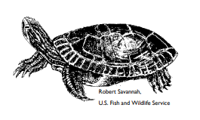
How can you begin to familiarize yourself with your land and resource areas?
You can put on your boots and walk the property yourself to investigate! The checklist below will help you. Look for the clues listed in the checklist. If you answer yes to any of the questions, you probably have wetlands on your property or close enough to your property that it is likely you will need a wetland permit to do a project. At this point it is important to contact the Commission office for further information on how to move forward in obtaining a permit.

*The checklist below is intended as a guide and not meant as a definitive determination regarding wetlands on or near your property. Any project within 100 feet of wetlands or 200 feet of a perennial stream requires a wetland permit. All projects within the 100-year floodplain and endangered species habitat are required to obtain permits too. Those maps can be found online in the links above. There are some exemptions for minor projects that could be determined by the Conservation Commission or a Wetlands Specialist. Do not assume that a project is exempt. An exemption under one law does not necessarily mean that it qualifies for an exemption under the Wetlands Protection Act. For example, certain agricultural activities that are exempt under another law/bylaw may not be exempt from getting a wetland permit. Always make the inquiry with the Conservation Commission.

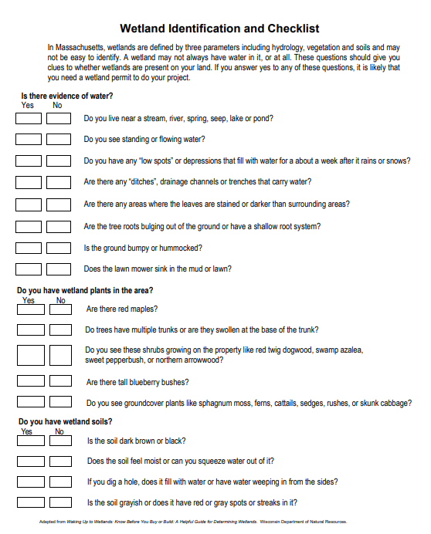

East Bridgewater Conservation Commission * 175 Central Street, East Bridgewater MA 02333 *(508) 378-1623 *

